**CLASSIFICATION OF MATHEMATICAL MODELS**

Based on the implementation details, mathematical models can be divided into two categories: **analytical and algorithmic.**

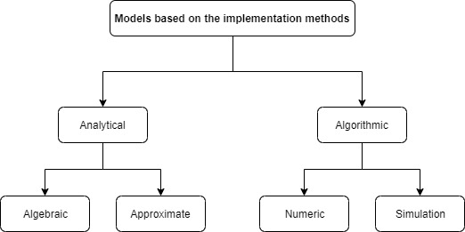

Figure 5. Mathematical models

**Analytical models**

Analytical models are the models that allow its output parameters to be expressed analytically, as a combination of **mathematic operations** over its inputs, controllable and uncontrollable parameters. Examples of such models can be the model of the trajectory of a ball thrown up with the known Velocity and under the known angle to the horizon. If the ball’s size and the wind speed are small and can be not taken into account, the trajectory can be expressed analytically as a straight formula.

Analytical model like this, we use mathematical formulas to describe the behavior of an object (in this case, the ball). These formulas take into account the initial conditions (like the speed and angle of the throw) and fundamental physical principles (like gravity) to predict where the ball will go. This is what we mean by saying the output (the ball's trajectory) can be expressed as a combination of mathematical operations over its inputs (initial speed, angle of throw, and gravitational force).

Furthermore, analytical models are divided into algebraic and approximate models.

1. **ALGEBRAIC MODELS**

**Algebraic models** are the models when a finite number of algebraic operations that can be used to relate the model outputs with the other model’s parameters.

Algebraic models are a type of analytical model where the relationship between the model's inputs and outputs can be described using a finite number of algebraic operations (like addition, subtraction, multiplication, division, exponentiation, etc.). These models are often used when a direct and straightforward mathematical relationship can describe the system or process being modeled.

### Example: Ohm's Law in Electricity

A classic example of an algebraic model is **Ohm's Law** in electrical engineering. Ohm's Law provides a simple algebraic relationship between voltage, current, and resistance in an electrical circuit. It is expressed as:

V=IR

Where:

* V is the voltage across the circuit component (in volts, V).
* I is the current flowing through the component (in amperes, A).
* R is the resistance of the component (in ohms, Ω).

#### Simplifications and Assumptions:

* **Linear Relationship**: Ohm's Law assumes a linear relationship between voltage and current, which is true for many materials under certain conditions (like constant temperature).
* **Constant Resistance**: The resistance R is considered constant, which is an approximation because in reality, resistance can change with temperature, strain, etc.

#### Application:

Using Ohm's Law, if you know any two of the three quantities (voltage, current, resistance), you can calculate the third. For example:

* If a resistor with a resistance of 5 ohms has a current of 2 amperes flowing through it, the voltage across the resistor is =2 A×5 Ω=10 VV=IR=2 A×5 Ω=10 V.

Ohm's Law is widely used in electrical engineering and physics to understand and design electrical circuits. It's a fundamental algebraic model that provides a clear, concise way to relate key electrical properties.

1. **APPROXIMATE MODELS.**

**Approximate models** are the models that cannot define the model outputs in a finite number of operations, for example, because of the complexity of the model. Instead, approximations are used in this kind of model.

An approximate model is a simplified representation of a more complex system, where certain assumptions are made to make the problem easier to solve or understand, while still capturing the essential features of the system. A good example of an approximate model is weather forecasting. The weather is influenced by a vast number of interacting factors like temperature, humidity, wind patterns, ocean currents, and more. To predict the weather, meteorologists use approximate models that take into account the most significant of these factors. However, due to the immense complexity of the atmosphere, these models can't perfectly predict weather patterns. They rely on approximations and probabilities, providing forecasts that are generally accurate but not exact.

This example illustrates the concept of approximate models: they simplify reality to make it more manageable, while still providing valuable insights into how systems behave.

**ALGORITHMIC MODELS**

Algorithmic models are a type of mathematical model that uses algorithms to represent and analyze complex systems or processes. These models are particularly prevalent in computer science, operations research, and systems engineering. In simple terms, an algorithm is a step-by-step procedure or set of rules to be followed in calculations or other problem-solving operations.

Algorithmic models are divided into numeric and simulation models.

1. **NUMERIC MODELS**

In numeric models, the mathematical description of the object of study (for example, a set of equations) is replaced with its simplified copy. This is achieved, for example, with the transition from continuous mathematical equations to discrete ones and then developing the computational algorithm to solve the final set of equations.

A straightforward example of a numeric model, where a continuous mathematical equation is simplified into a discrete form for computational purposes, is the numerical solution of a simple linear equation. Consider the differential equation representing a cooling process, often described in physics:

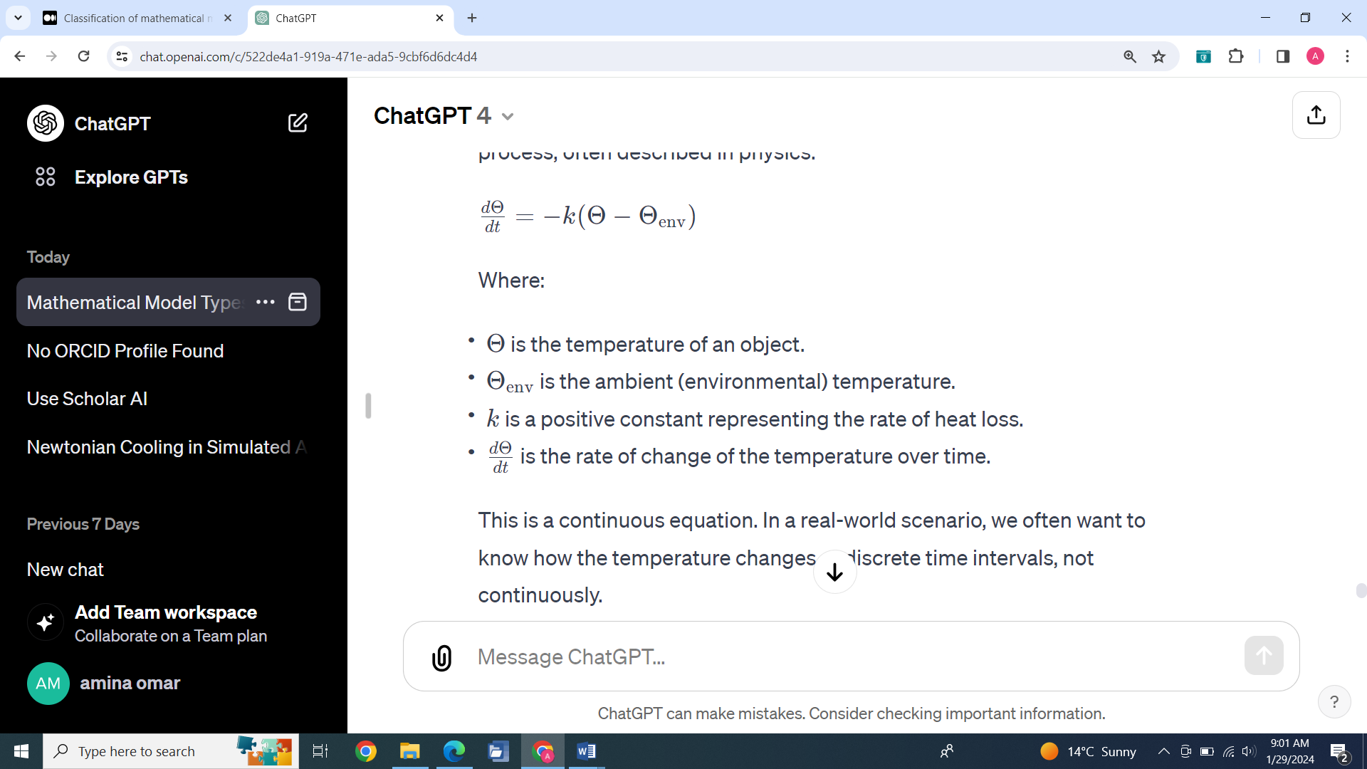

This is a continuous equation. In a real-world scenario, we often want to know how the temperature changes at discrete time intervals, not continuously.

### Numerical Approximation (Discretization):

We can approximate this continuous process by breaking time into small discrete steps. Let's say we are interested in how the temperature changes every minute. We could rewrite our equation in a discrete form:

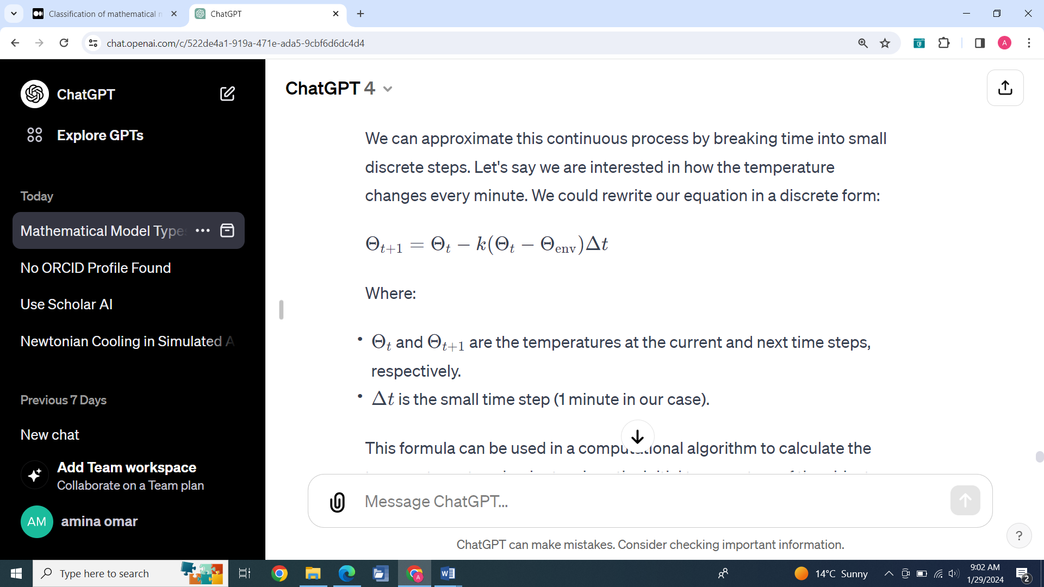

This formula can be used in a computational algorithm to calculate the temperature at each minute, given the initial temperature of the object.

### Simple Example:

Suppose an object at 100°C is placed in a room with an ambient temperature of 20°C. Assume =0.01k=0.01 per minute. We want to compute the temperature of the object at each minute.

Using the discrete formula:

* At =0t=0 minutes, Θ0=100Θ0​=100°C.
* At =1t=1 minute, Θ1=Θ0−0.01(Θ0−20)×1Θ1​=Θ0​−0.01(Θ0​−20)×1.

By repeating this calculation for each subsequent minute, we can numerically model the cooling process of the object over time.

### **Why Use Numerical Models?**

Numerical models like this are crucial when exact solutions are difficult or impossible to find. They allow for approximate solutions over discrete time steps or elements, making it possible to simulate and predict the behavior of systems over time. This method is widely used in engineering, physics, finance, and many other fields for various applications.

1. **SIMULATION MODELS**

In simulation models, the object of study itself is replaced with its simplified discrete copy. For example, a liquid flow inside a volume can be modeled by the means of computational flow dynamics, where the entire volume of liquid is split into a mesh of elementary volumes, and then a set of equations is defined for each of the volumes.

The figure below shows the classification of mathematical models based on the implementation methods.

**Types of Simulation Models**

* Simulation models can be classified as being static or dynamic, deterministic or stochastic and discrete or continuous.
* A Static simulation model represents a system, which does not change with time or represents the system at a particular point in time.
* Dynamic simulation models represent systems as they change over time.
* Deterministic models have a known set of inputs, which result in a unique set of outputs.
* In the Stochastic model, there are one or more random input variables, which lead to random outputs.
* Systems in which the state of the system changes continuously with time are called Continuous systems

while the systems in which the state changes abruptly at discrete points in time are called Discrete systems.

**Stochastic vs. Deterministic**

Stochastic simulation: a simulation that contains random (probabilistic) elements,

Examples

* Inter-arrival time or service time of customers at a restaurant or store
* Amount of time required to service a customer
* Output is a random quantity (multiple runs required to analyze output)

**Deterministic simulation: a simulation containing**

* no random elements

Examples

* Simulation of a digital circuit
* Simulation of a chemical reaction based on differential equations
* Output is deterministic for a given set of inputs

**Static vs. Dynamic Models**

**Static models**

Model where time is not a significant variable

Examples

* Determine the probability of a winning solitaire hand
* Static + stochastic = Monte Carlo simulation
* Statistical sampling to develop approximate solutions to numerical problems

A simple example of a static model in mathematics is the solution to a linear equation in two variables. Consider the linear equation:

y=2x+3

This equation represents a straight line on a Cartesian coordinate system.

**Dynamic models**

Model focusing on the evolution of the system under investigation over time

A simple and classic example of a dynamic mathematical model is the basic model of population growth. The most fundamental version of this model uses a differential equation to describe how a population changes over time, considering a constant rate of growth. This model is known as the exponential growth model.

Here's the mathematical representation:

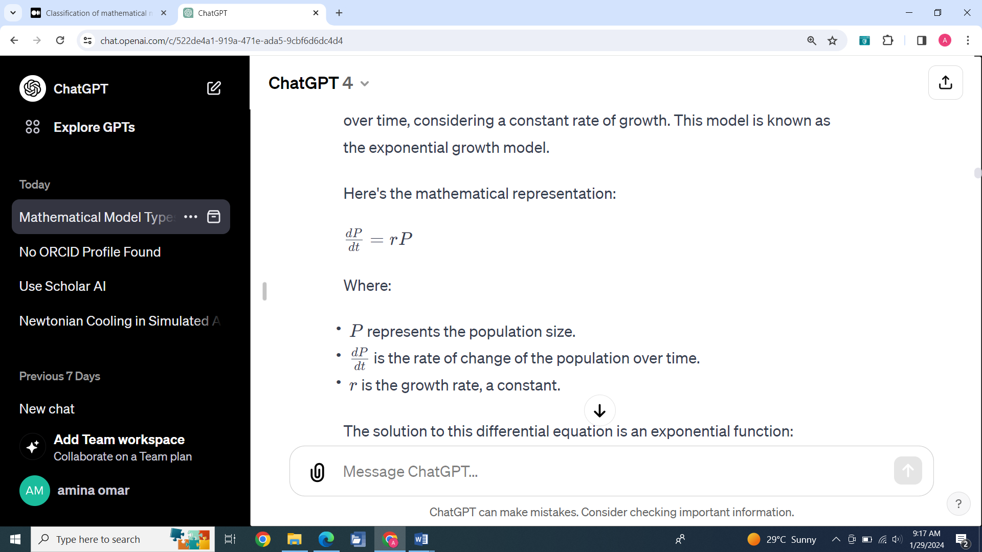

The solution to this differential equation is an exponential function

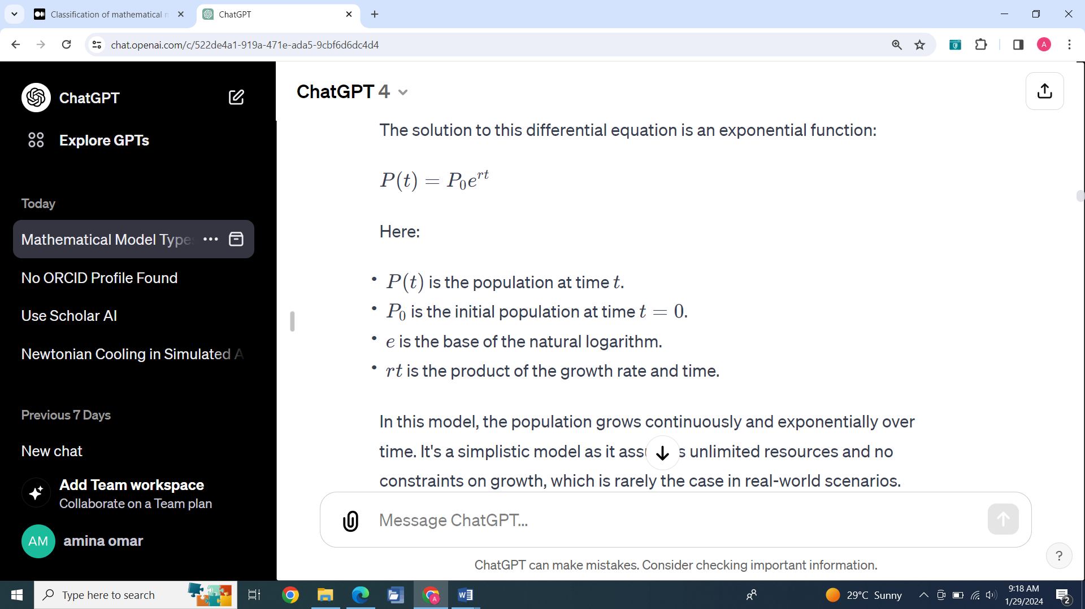

In this model, the population grows continuously and exponentially over time. It's a simplistic model as it assumes unlimited resources and no constraints on growth, which is rarely the case in real-world scenarios. However, it serves as a fundamental starting point for understanding more complex dynamics in population biology and ecology.

**Continuous vs. Discrete**

The discrete State of the system is viewed as changing at discrete points in time

* An event is associated with each state transition
* Events contain timestamp

A simple example of a discrete model can be found in the concept of a queue, such as the line of customers waiting at a bank. In this model, the customers and their arrival and service times are treated as discrete events.

### **Queue at a Bank: A Discrete Model**

Consider a queue at a bank where customers wait to be served by a teller. Here's how this scenario can be modeled discretely:

* **Discrete Entities**: Each customer is a discrete entity. They arrive at the bank at specific, countable moments in time.
* **Discrete Events**: The arrival of a customer is a discrete event. Similarly, the beginning and end of service for each customer are discrete events.

In summary, the queue at a bank is an excellent example of a discrete model, where the entities (customers) and events (arrivals and departures) are distinct and countable. This model helps in understanding and managing systems where events occur at separate points in time.

**Continuous**

* The state of the system is viewed as changing continuously across time
* System typically described by a set of differential equations

A simple example of a continuous model is the monitoring of temperature over time. In this model, temperature is recorded as a continuous variable that changes smoothly and steadily, without discrete jumps or intervals.

### **Temperature Monitoring: A Continuous Model**

Consider a thermometer used to record the outdoor temperature throughout the day. Here's how this scenario can be modeled continuously:

1. **Continuous Variable**: Temperature is a continuous variable. It can take on any value within a range and changes in a fluid, uninterrupted manner.
2. **Time Dependency**: The temperature at any moment is dependent on time, and time is also treated as a continuous variable.
3. **Smooth Changes**: Unlike discrete models, where changes occur in distinct steps, the temperature changes smoothly over time.

**MODELS TO BE COVERED: MONTE CARLO. DISCRETE AND CONTINUOUS**

**STEPS IN A SIMULATION STUDY**

* **Problem formation Problem formation**
* **Model construction**
* **Data Collection**
* **Model programming**
* **Validation**
* **Design of experiment**
* **Simulation run and analysis**
* **Documentation**
* **Implementation**

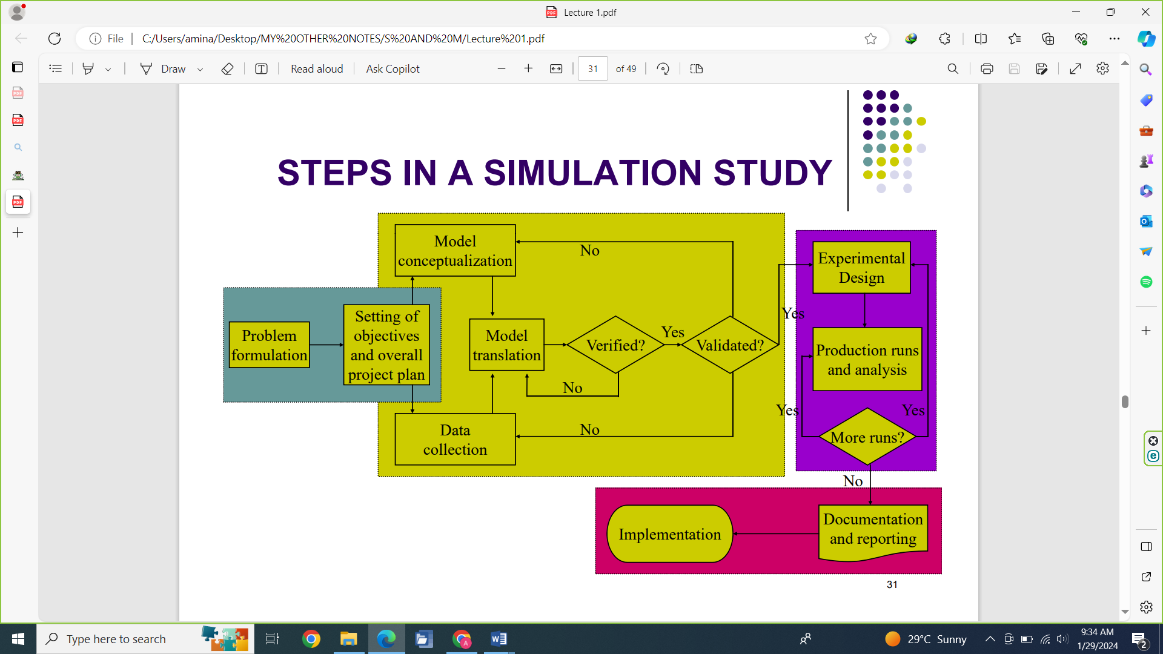

Performing simulation and modeling involves several key steps, each crucial for ensuring the accuracy and effectiveness of the model. These steps typically include:

1. Problem Definition:
   * Clearly define the problem or system you want to model.
   * Identify the objectives of the simulation, including what questions you want to answer or what aspects of the system you want to explore.
2. System Analysis and Conceptual Modeling:
   * Analyze the real-world system to understand its components and how they interact.
   * Develop a conceptual model that represents these components and interactions. This model is an abstract representation of the system, often in the form of flowcharts or diagrams.
3. Data Collection:
   * Gather data that will be used to parameterize and validate the model. This may include historical data, experimental data, or data from existing literature.
   * Ensure the data is accurate and relevant to the system being modeled.
4. **Model Development:**
   * **Translate the conceptual model into a mathematical or computational model. This involves selecting the appropriate modeling approach (e.g., discrete, continuous, stochastic) and writing the necessary equations or algorithms.**
   * **Implement the model using appropriate software tools or programming languages.**
5. Verification and Validation:
   * Verification: Ensure that the model is implemented correctly and is free from errors. This is about making sure the model works as intended.
   * Validation: Confirm that the model accurately represents the real-world system. This involves comparing model outputs with real-world data or established theories.
6. Simulation Experiments:
   * Run the model under various conditions to simulate different scenarios. This may involve adjusting input parameters or initial conditions to explore how they affect the system's behavior.
   * Analyze the results of these experiments to gain insights into the system.
7. Interpretation and Analysis:
   * Interpret the results of the simulation in the context of the original problem or objectives.
   * Analyze the outputs to draw conclusions, make predictions, or inform decision-making processes.
8. Documentation and Reporting:
   * Document the model development process, the assumptions made, the methodologies used, and the results obtained.
   * Prepare reports or presentations to communicate findings to stakeholders or decision-makers.
9. Implementation and Use:
   * Use the model for its intended purpose, which might be decision support, policy development, or further research.
   * Continuously monitor and update the model as needed to ensure its ongoing relevance and accuracy.

Each of these steps is crucial in ensuring that the simulation and modeling process is thorough, accurate, and yields useful results. The specific details of each step can vary greatly depending on the nature of the system being modeled and the objectives of the simulation

